[Fund Name]
This factsheet explains the McCloud judgment and changes to the Local Government Pension Scheme (LGPS) in England and Wales.

The changes may affect you if:
- you were paying into the LGPS or another public service pension scheme before
1 April 2012
- you were paying into the LGPS between 1 April 2014 and 31 March 2022 and
- you have been a member of a public service pension scheme without a continuous break of more than 5 years.


What is the McCloud judgment?
When the Government reformed public service pension schemes in 2014 and 2015, they introduced protections for older members. In December 2018, the Court of Appeal ruled that younger members of the judges’ and firefighters’ pension schemes had been discriminated against because the protections did not apply to them.
This ruling is called the McCloud judgment, after a member of the Judicial Pension Scheme involved in the case. Because of the ruling, all public service pension schemes that provided protection, including the LGPS, have been changed.
The changes are called the McCloud remedy. They remove the age discrimination found in the McCloud court case.

Will it change anything?
In 2014, the LGPS changed from a final salary scheme (a pension based on your pay when you leave) to a career average scheme (a pension which builds up based on what you earn each year). Older members who were closer to retirement were protected from the changes. When a protected member took their pension, the pension from the career average scheme was compared with the pension that would have built up in the final salary scheme. The member received the higher amount. This protection is called the underpin.
To remove the McCloud age discrimination, qualifying younger members will now receive underpin protection too. Underpin protection only applies to pensions built up in the remedy period, between 1 April 2014 and 31 March 2022. Underpin protection stopped earlier if you left the Scheme or reached your final salary normal retirement age (usually 65) before 31 March 2022.
From 1 April 2022, there is no underpin protection. Pensions built up after this date are based on the career average scheme only.


Am I protected?
You are protected by the underpin if you were:
- a member of the LGPS or another public service pension scheme before 1 April 2012 and
- a member of the LGPS at any time between 1 April 2014 and 31 March 2022 as long as you did not have a disqualifying gap.
A disqualifying gap is a continuous period of more than five years when you were not a member of a public service pension scheme.

Am I affected?
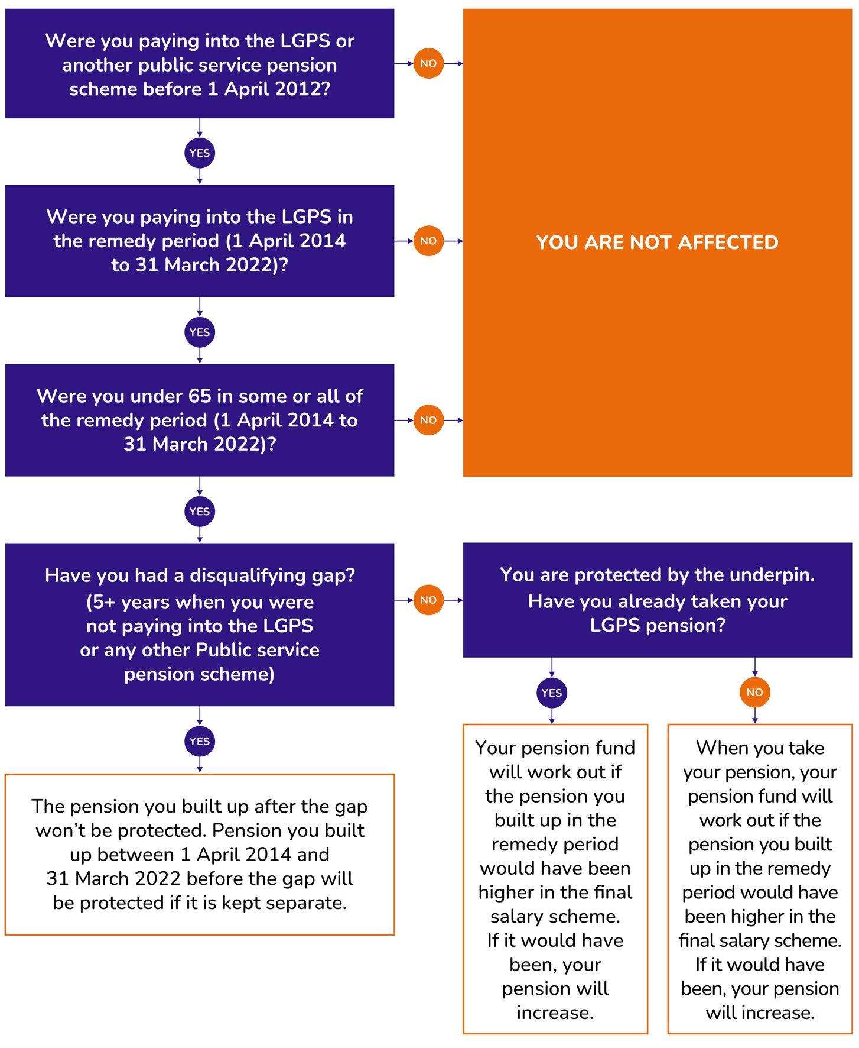

Key dates

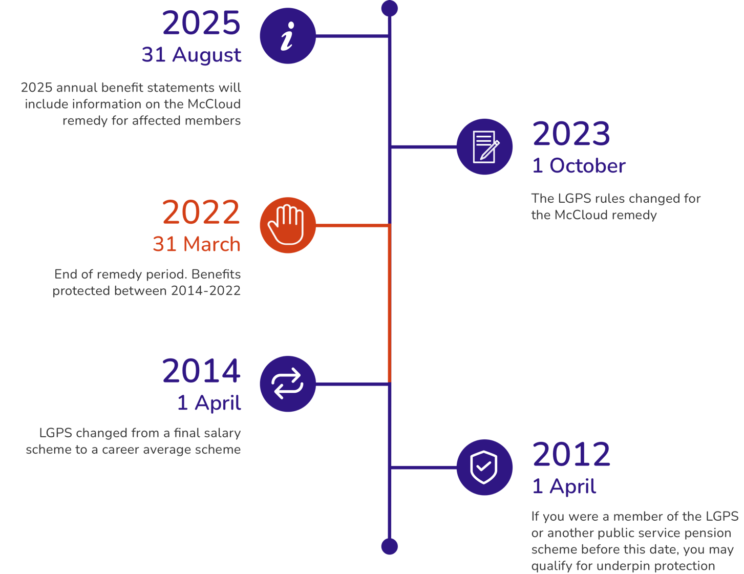

What do I need to do?
You do not need to do anything. If you qualify for underpin protection, we will work out if your pension is due to increase when you take it. If you are an active or deferred member, we will give you an estimate of how the underpin may affect your pension in your 2025 benefit statement. If we are already paying your pension, we will review it. If you are due an increase, we will pay you arrears of pension payments with interest. We will do this as soon as we can after 1 October 2023. We have many thousands of pensions to review and this process will take many months.


Will my pension increase?
Most members won’t see an increase because the pension they build up in the career average scheme is higher than the pension they would have built up in the final salary scheme. If there is an increase, it is likely to be small.

Do the changes affect me if I qualified for original underpin protection?
If you qualified for underpin protection when you took your pension before 1 October 2023, you may still be affected. We will work out if you are due an addition to your existing pension under the new rules. We will do this as soon as we can after 1 October 2023.


How can I find out more?
This factsheet doesn’t cover all circumstances or provide a detailed explanation of the McCloud remedy,
which is set out in legislation.
For more information about the McCloud remedy, visit the McCloud section of the LGPS member website www.lgpsmember.org/McCloud-remedy.
To find out more about our McCloud project and what you can expect from us, ****[pension fund to input website or contact information].****

